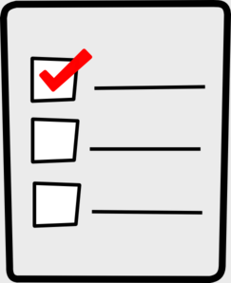
Weekly Checklist
Week of April 13th

Required Assignments | Required Assignments
Math:  - Video for 12.5  - 12.5 Homework (regular OR Challenge)  - Video for Mid-Chapter Review  - Lessons 1-5 QUIZ  Science:  - Video for pages 18-23  - Questions for pages 18-23 | Reading:  - Journal prompts  - Good Morning Sunshine or Miss Morgan’s students do fluency  - Main idea video  - Main idea quiz  - Comprehension Cards  - Linking verb video  - Linking verb quiz  Social Studies:  - Midwest state video  - Questions about the video  **Remember to work on your Midwest State Report. Send me a picture of it when you are done.

